THE BULLETIN THE BULLETIN
JULY/AUGUST 2021 VOLUME 101 NUMBER 4
THE OFFICIAL PUBLICATION OF THE DENTAL SOCIETY OF WESTERN PENNSYLVANIA

SUMMER EDITION

THE BULLETIN

DR. V. LYNNE COCHRAN
EDITOR

EDITORIAL REVIEW BOARD
DR. V. LYNNE COCHRAN
DR. CYNTHIA SCHULER
DR. RAYMOND LANCIONE

DSWP OFFICERS

DR. JOHN E. PAWLOWICZ
PRESIDENT

DR. DENNIS A. ZABELSKY
PRESIDENT ELECT

DR. JAME A. TAUBERG
VICE PRESIDENT

DR. MICHAEL J. KORCH
IMMEDIATE PAST PRESIDENT

DR. CYNTHIA L. SCHULER
SECRETARY

DR. GREGORY MILLER
ASSISTANT SECRETARY

DR. MICHAEL J. GANS
TREASURER

DR. HENRY J. BITAR, JR.
ASSISTANT TREASURER

DR. MICHAEL J. GANS
PDA TRUSTEE

DR. LINDA K. HIMMELBERGER
ADA TRUSTEE

ADA THIRD DISTRICT TRUSTEE BLOG
DR. LINDA HIMMELBERGER
June 2021

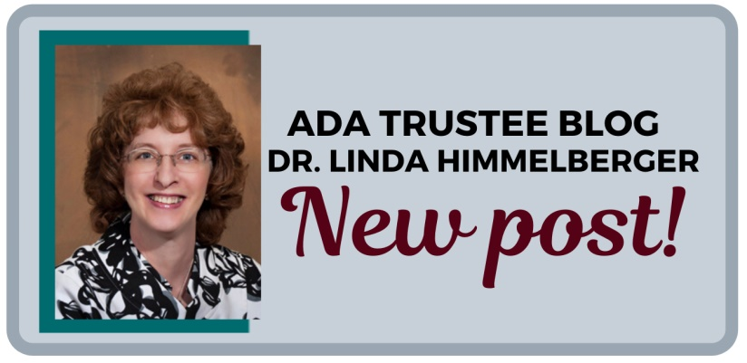
“Why isn’t the ADA doing anything about dental insurance?” is a recurring lament among members and non-members alike. In fact, the ADA is doing a lot about dental insurance at the organizational, federal, state and industry level to reform the insurance sector. Following is an outline of some of the many ADA dental insurance initiatives.

1. Lawsuit against Delta Dental: The ADA and two individual dentists filed class-action lawsuit against the Delta Dental Plans Association, its affiliated national entities and 39 independent Delta Dental companies, alleging the provider network has engaged in anticompetitive conduct and violated federal antitrust laws. This lawsuit remains ongoing and serves as the strongest action against a major dental insurance carrier.

2. Federal Advocacy: The ADA successfully lobbied Congress for the repeal of the McCarran-Ferguson Act’s exemption from certain provisions of the antitrust laws of healthcare insurance. The ADA believes that the exemptions provided in this 1945 law have resulted in a general absence of scrutiny of health insurance companies by the federal government. In fact, before the exemption was eliminated Delta Dental asserted it as a defense to the ADA’s class action lawsuit. ADA is hopeful that the FTC and DOJ will now more actively investigate suspected anticompetitive conduct and pursue sanctions when it is found—creating a fairer dental insurance marketplace.

3. State Advocacy: At the state level, the ADA is supporting several state dental associations with robust advocacy resources and grant funding to reform dental insurance. For example, this support helped 41 states pass laws limiting insurers’ ability to dictate dentists’ charges for non-covered services. Almost half of the states require insurers to notify dentists about leased networks, and some now must allow dentists to opt out of the lease. Over 80 different dental insurance reform proposals are active just in 2021, including PDA’s continuing efforts to enact Assignment of Benefit (AoB) legislation.

4. Industry solutions:
a. Bento: Bento, endorsed by the ADA, is a start-up technology company that fully replaces a dental benefit administrator for self-insured employers. This means there is no middle man second-guessing the dentist’s treatment plan. Using Bento’s award-winning and easy-to-use app, patients approve their treatment plans (and not consultants) on their phones while still in the chair! Dentists get paid directly – with everything being automated and electronic. The Bento platform even allows dentists to offer in-office plans. Learn more about Bento at ADA.org/Bento. Bento supports real-time eligibility & benefits verification, real-time claims adjudication, fast and easy direct payment to dental offices, along with cost transparency for patients, ultimately leading to a better dentist-patient relationship.

b. Credentialing: Every single insurance carrier requires dentists participating in their network to re-credential, usually every three years. On average it appears dentists participate with at least 15 carriers. This translates to completing the same paperwork 15 times every 3 years. Over 70,000 dentists now use the ADA credentialing service, powered by CAQH ProView, to digitally store and submit their credentialing paperwork across different carriers—allowing dentists and their staff to focus on patients and the practice. Learn more about the credentialing solution at ADA.org/credentialing.

5. Education: Sometimes it may help to simply understand the landscape better to succeed! To help train office staff to file claims efficiently, the ADA offers courses through the ADA’s Coding Academy. Additionally, there are new free webinars offered each month and ready to use resources and Frequently Asked Questions at ADA.org/dentalinsurance, all aimed at providing solutions to complex dental insurance questions to our members.

The next time someone asks you “what is the ADA doing about dental insurance?” you can answer “a lot!”

Please support ADPAC and PADPAC, and take advantage of the industry and educational programs that the ADA endorses and sponsors. The ADA has got your back!
(The information in this article has been adapted from materials prepared by Krishna Aravamudhan and Roxanne Yaghoubi of the American Dental Association.)
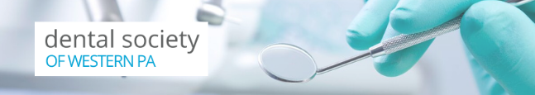
The Dental Society of Western PA (DSWP) is excited to extend you the opportunity to attend PDA's Leadership Conference! The society will reimburse your attendance at the conference, Leading through Change, to be held July 23-24, 2021 at the Radisson Hotel Harrisburg.

Reimbursement will include your conference registration and hotel room. This opportunity is available to the first six DSWP members under the age of 45 in an effort to foster new leadership within the society.

To reserve your spot for DSWP-sponsored attendance, please contact DSWP at threeriversdental@verizon.net, then register for the Leadership Conference at www.padental.org/calendar.

The full-day conference on Saturday is preceded by a networking reception at 8:30 p.m. on Friday night. Join your colleagues for the first PDA in-person meeting of 2021 and hone your effectiveness as a leader in fast-paced sessions including:
- Leading Through Change presented by Dr. Kathy O'Loughlin, ADA Executive Director
- Diversity Today, Being More Inclusive Tomorrow presented by Mauricio Velásquez, MBA, President and CEO of The Diversity Training Group
- The Economics of Great Communication presented by Dr. Robert Maguire, former president of the New Hampshire Dental Society
- Team Building Exercises lead by Autumn Wolfer, Manager, ADA Dental Society Outreach, and
- a special presentation from Dr. Bruce Terry who will recount his journey to summit Mt. Everest!
With questions about this opportunity, please contact DSWP at threeriversdental@verizon.net. Your participation will help drive our organizations forward - we look forward to seeing you at the Conference!
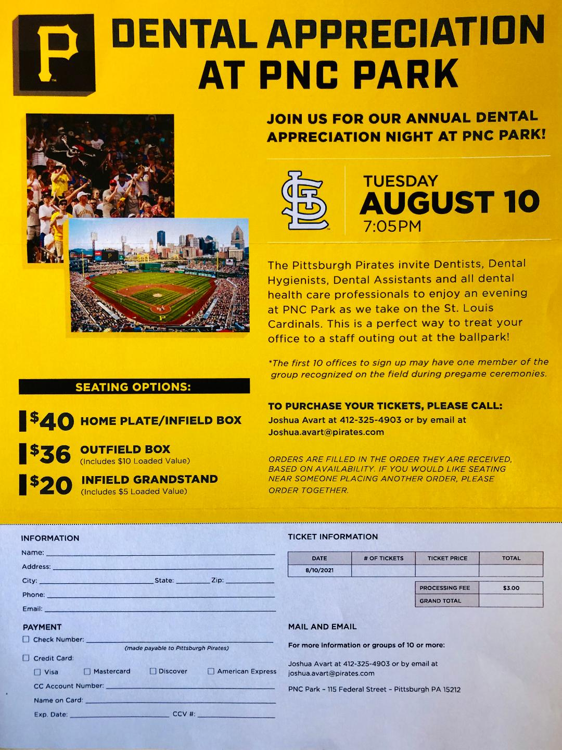
UPDATE
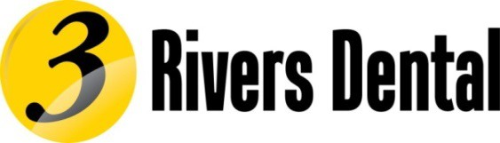CONFERENCE

Please ADJUST your calendars with the NEW DATES for the
Three Rivers Dental Conference at the beautiful
Nemacolin Woodlands Resort

NOVEMBER 3 & 4, 2022

Out of an abundance of caution the 2021 meeting will be replaced by a series of one day continuing education seminars that maybe virtual or in person as circumstances permit. Your safety and the safety off all attendees is our priority.
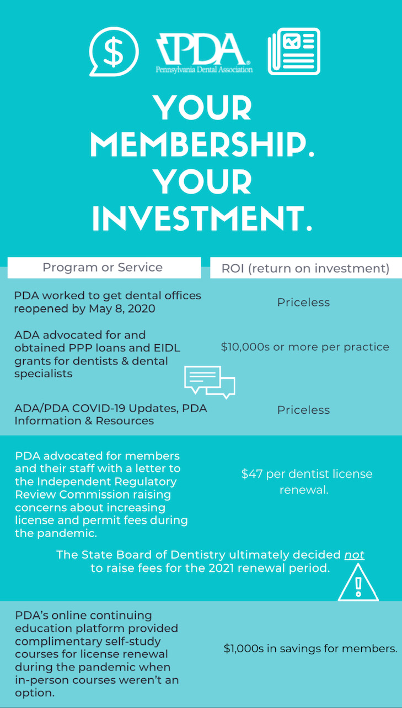

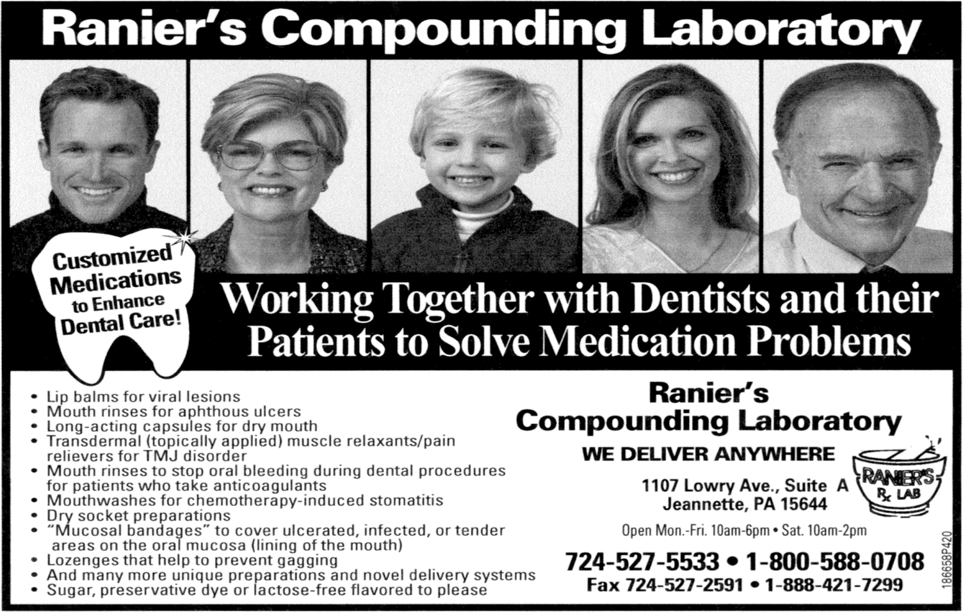

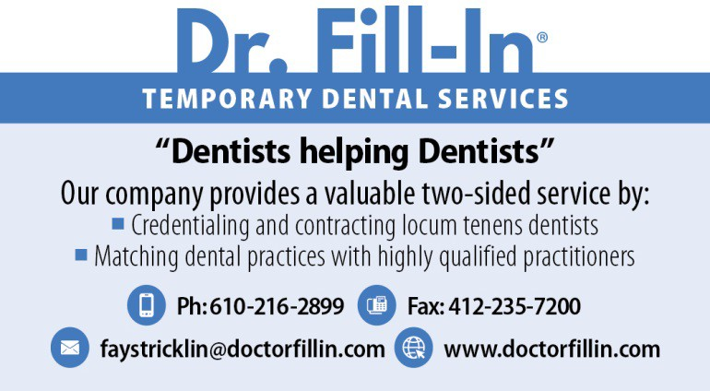
A PLEA TO THE MEMBERSHIP:
To all members of the DSWP

Our volunteers and elected officers are getting increasingly overloaded with the duties placed upon them. We can use help from members in good standing in such positions as assistant Editor to help produce the Bi-monthly DSWP Bulletin and positions on DSWP Committees. To volunteer in some capacity please contact Dr. Cynthia Schuler at the DSWP office: 412-321-5810 or email threeriversdental@verizon.net. For those of you who wish to apply for the Assistant Editors position please send a current resume or CV to : Attention Assistant Editor Position to the above DSWP email as well.
Thank you for your dedication,
Dr. V. Lynne Cochran, Editor DSWP Bulletin

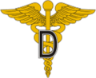
In June 2020, The ADA announced our first-ever endorsement of a dental benefits administrator – Bento.
Bento brings automation into the traditional dental benefits administration sector. Their platform currently offers two separate products to support dentists:
- In-office membership dental plans
- Bento’s PPO Network for self-funded employer groups

There are a number of advantages Bento provides in comparison to other benefits administrators:
- Real-time eligibility & benefits verification and claims adjudication
- Fast and easy direct payments to dental offices
- Cost transparency for patients
- A simplified administrative system with no consultant reviews for “medical necessity”
- Easy to use app experience for both patients and the front desk
- The platform also supports in-office plans that allow dentists to easily create and set up fully customizable in-office plans that align with the needs of their practice and patients
- No set-up fees for all dentists who use Bento’s in-office plans
- Dentists are not required to join the Bento network when using Bento to administer in-office plans
As an added benefit, ADA members will receive a 20% discount on their monthly subscription for purchased in-office plans.
For more information contact Bento at bento.net/dentist or call the toll free number 800-734-8484.

Clym Environmental Services, LLC
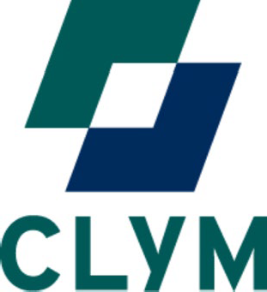

New Castle, PA 16101
PRICING QUOTATION

To: Dental Society of Western PA Members Date: Valid thru 2021

From: Matthew Spady, Clym Environmental Services Subject: Compliance & Waste Package

SPECIAL COMPLIANCE PACKAGE PRICING INCLUDES:

Written Safety Plans: (with Safety Binder)

- Exposure Control Plan (required by Bloodborne Pathogens Standard)
- Hazard Communication Plan (required by HazCom Standard)
- Department Of Transportation Medical Waste Shipment Protocol (DOT)
- Emergency Action Plan (EAP)
- Radiation Protection
- Infection Control
- HIPAA
- Workplace Violence Prevention
- Respiratory Protection

Annual Training: (in-house)

- Bloodborne Pathogens Safety
- HAZCOM / GHS
- DOT
- Infection Control
- HIPAA
- X-ray
- CPR
- Child Abuse
- Respiratory Protection (N95)
- N95 Fit testing (certain fees may apply)
- Medical Emergencies in the dental setting

Annual Services:

- Annual Updates
- Safety Chat
- Mock OSHA Audit
- New hire training via zoom

SPECIAL PACKAGE PRICING $1,500.00 per year
(12 CE’s awarded over a license period)
Call today to set up a no obligation MOCK OSHA audit today: 724-924-0997
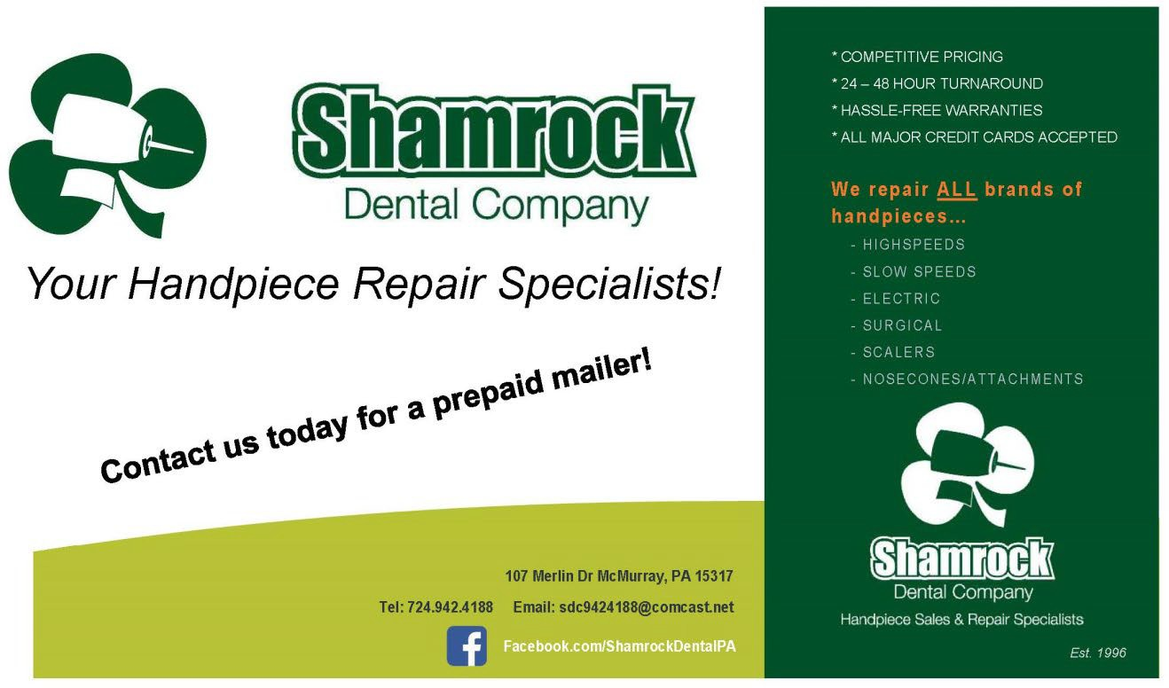

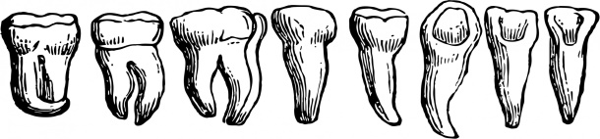
LETTERS TO THE EDITOR/MEMBER INPUT/COMMENTS
The Bulletin welcomes input from its members in various forms. This is your publication and forum. We welcome comments, opinions and even articles from the membership. Thank you for your input and support.
THE DENTAL VAULT

From ancient times to astronauts, people have had to get creative when cleaning their teeth! Ancient Egyptians would use a frayed stick to clean their teeth and the Ebers Papyrus even included a recipe for a type of toothpaste. A 17th century Chinese encyclopedia credits the invention of the toothbrush as we know it today (a long handle with bristles) in 1498. Prior to mass-production in 1873 by Colgate, dentists would provide their patients with their own toothpaste. In the 1960s a new type of toothpaste needed to be invented for space travel! Originally dubbed NASAdent, the idea for an ingestible toothpaste was then repurposed for young children. Luckily for us, we've come a long way from frayed sticks!
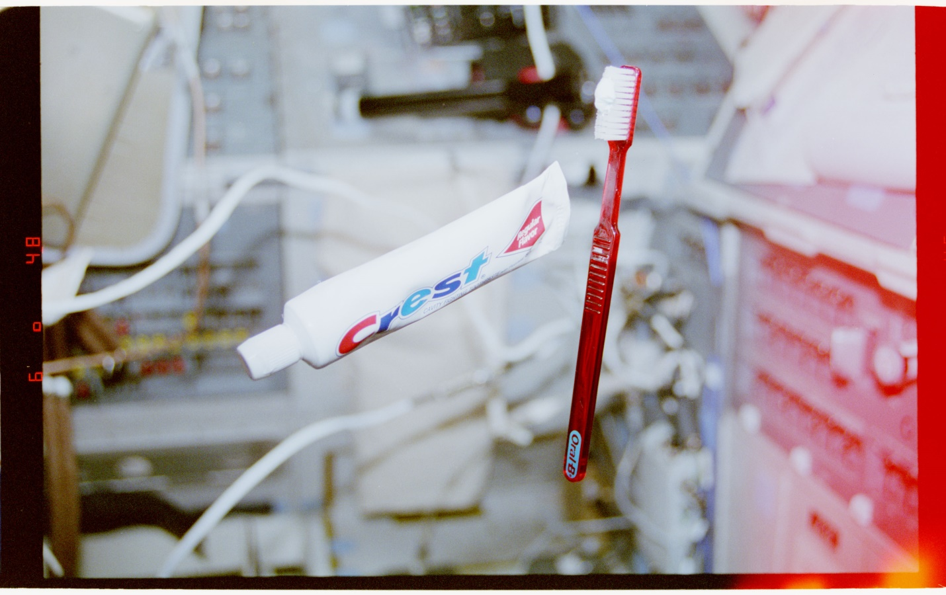
Toothbrush and tube of toothpaste floating in the flight deck, 8/2/1995; National Archives Identifier 22919767.

From time to time we will be including snippets of historical information. We welcome you to submit photos or articles from your vault that we may choose to publish in the Bulletin. Watch for yours!

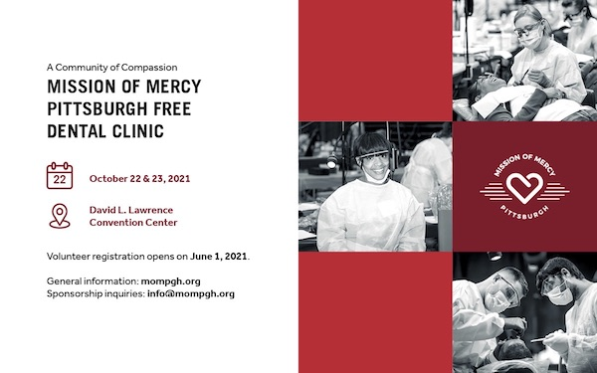

We are all in this together—and with your help we can make a difference!

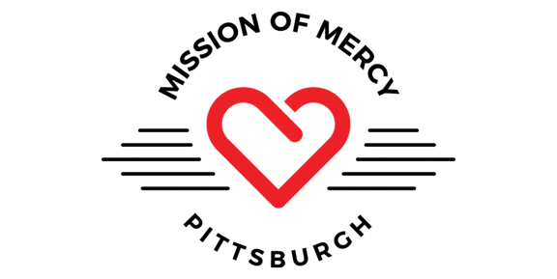

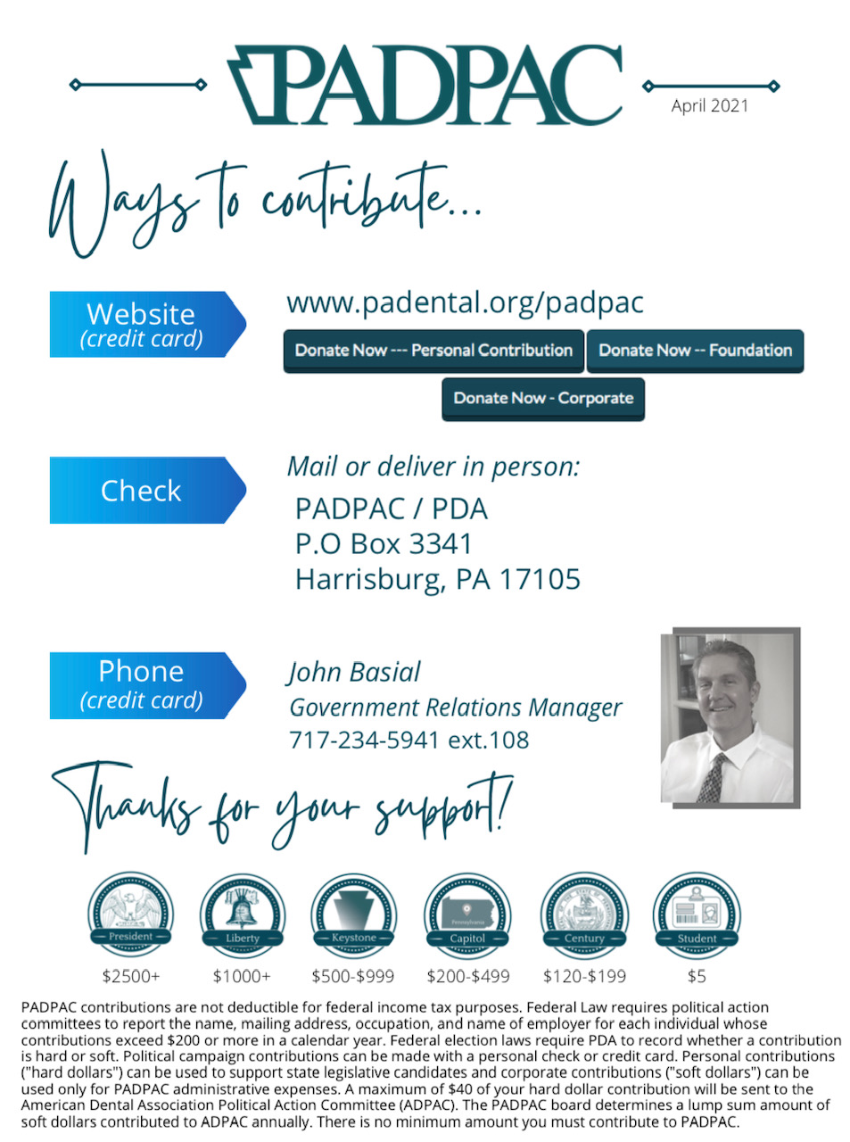
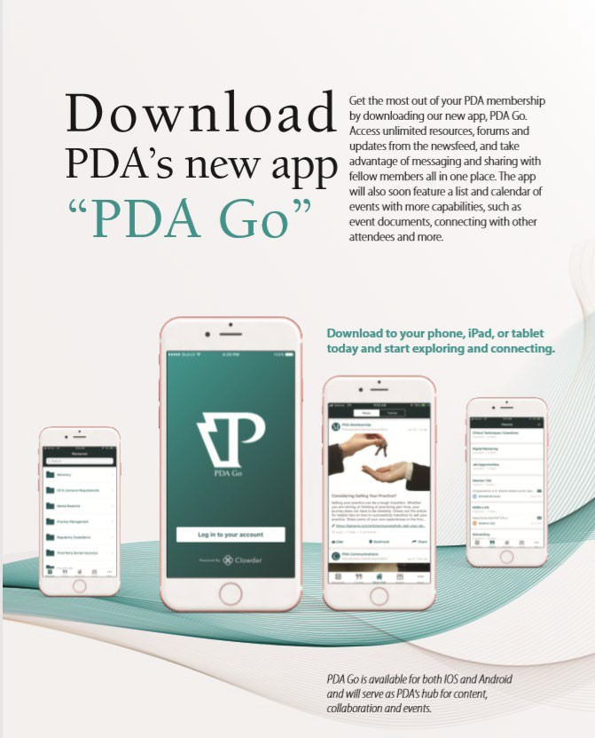

PDA Webinars Available
Virtual gatherings and informative webinars have become a big part of things during the pandemic. PDA has provided numerous virtual programs, and you can find all of the recorded webinars, including the Leadership e-Series “Bridging the Info Gap” programs, on the PDA Go mobile app. On the app, go to Resources and find the Webinars folder containing a single interactive document. You can also find webinars on PDA’s website, on the Membership tab, by scrolling down and clicking on Webinars to visit the page with all available recordings.

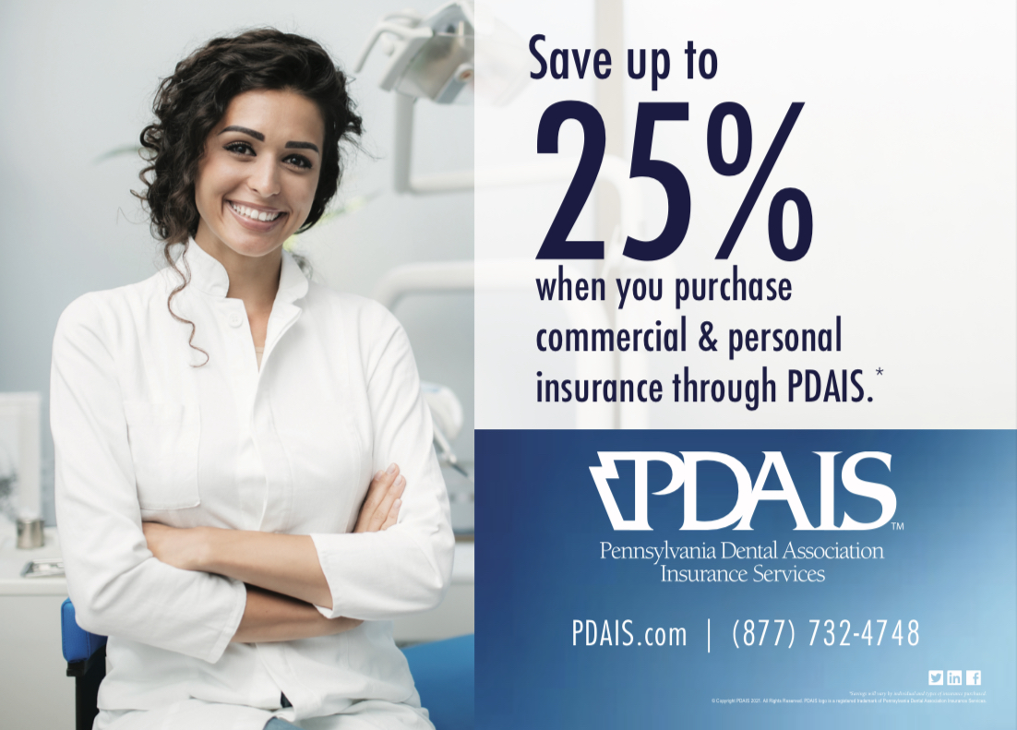
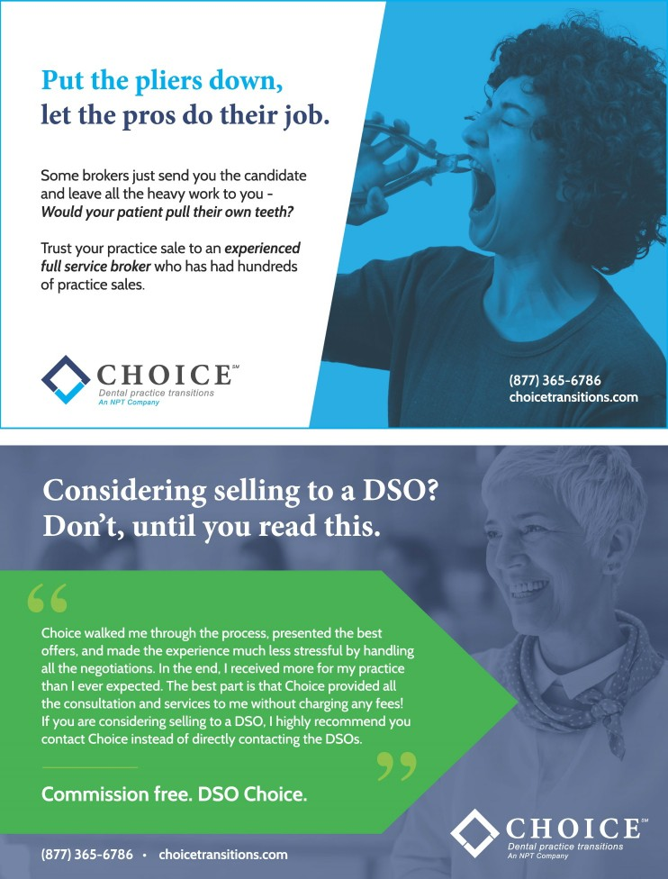

CLASSIFIED ADS
MAY/JUNE

BUYING OR SELLING A PRACTICE? NEED AN ASSOCIATE? LOOKING FOR A NEW POSITION? NEED A VALUATION?
While United Dental Brokers of America (UDBA) conducts business throughout the USA, it is headquartered in Pittsburgh. UDBA has sold practices ranging from $200K to $7.5 million along with placing associates throughout the country. Please call us for an absolutely-free consultation. UDBA is a firm with a National Reach, but a Personal Touch!

Bob Septak (412) 931-1040, bob@udba.biz – www.udba.biz

ADVERTISING POLICY

Classified: Members – a minimum charge of $40 for the first 35 words. Non-Members – a minimum charge of $50 for the first 35 words – fifty cents for each additional word. $10 for a Box number. ALL classified ads must be paid for upon submission and must be typewritten or printed.

Policy: Although the DSWP believes that advertisements published herein are from reputable sources, the Society neither investigates the offers or assumes responsibility for them. The DSWP reserves the right to decline or withdraw advertising.

Box Numbers: Box numbers are provided to insure the confidentiality of our advertisers. Replies to box number ads should be addressed to: Classified Department, Box Number
, The Bulletin. The box number must appear on the envelope; names of box number advertisers cannot be revealed. All responses will be mailed, unopened, to the advertiser immediately upon receipt.
Mailing Address: The Bulletin, 900 Cedar Avenue, Pittsburgh, PA 15212

The Bulletin is published bimonthly and represents the nine counties the Dental Society of Western Pennsylvania comprises: Allegheny, Armstrong, Beaver, Butler, Fayette, Greene, Indiana, Washington, and Westmoreland. The DSWP, PDA, ADA or any of its subsidiaries, councils, or agencies does not necessarily endorse statements of opinion. Letters to the Editor must be signed and may be edited. Communications should be addressed to the Editor,
900 Cedar Avenue Pittsburgh, PA 15212.
The Society telephone: (412) 321-5810. FAX: (412) 321-7719.
Our website is www.dswp.org
The Society’s email address is threeriversdental@verizon.net

All copy for publication in The Bulletin must be in the hands of the editor by the 1st of the month preceding the next issue. Copy received after that date, if still newsworthy, may be published in the next issue.

DSWP
Dental Society of Western Pennsylvania

